**Stock management**

This is the back office for managing your stock including inventories, suppliers, and warehouses. The inventories are divided into three different lists by the system, which is as follows:

* Active Listing
* Inactive Listing
* Out of Stock

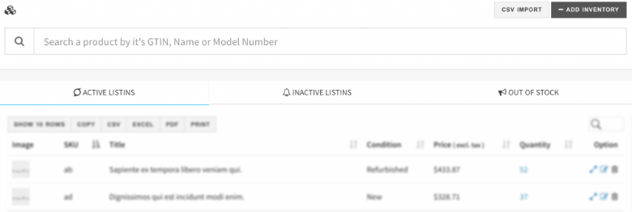

Several features for stock management are there with IndoMarche that are:

* Suppliers
* Warehouse
* Add Stock
* Bulk Upload

**Suppliers**

All of the supplier profiles can be set up in the system with this module. With each new addition in the inventory, you will get access to select the supplier for the same.

STOCK >> SUPPLIERS

**Warehouses**

All of the warehouses available with you can be added to the system. With each product’s addition in the inventory, you can select the warehouse from where the product will be shipped.

STOCK >> WAREHOUSE

**Add Stock**

To add a product to your stock, you must click on the ADD INVENTORY button. If there is a possibility to create a variant in the inventory, then ADD TO INVENTORY WITH VARIANT option will be displayed, otherwise, ADD TO INVENTORY button is shown. You can select the right option from the available ones that fit best for your needs. Be honest with everything thinking from a buyer’s perspective.

STOCK >> INVENTORIES >> ADD INVENTORY

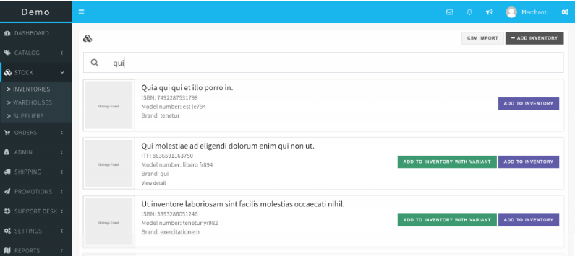

If you cannot find a product, then it must be unavailable on the marketplace yet. To solve this issue, you can create the product by visiting the CATALOG PRODUCTS section and then add the inventory.

*Basic Info*

This section contains all the information parts that are required for the description of a product. Carefully add the title and listing, as it solely should be enough to give an idea of the product, and then the description must be there with in-depth detailing of the product. It must have everything about the product that the customer might want to know.

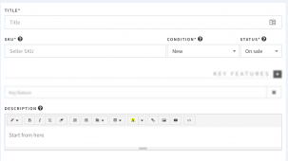

*Images*

This is the most crucial part of the product description in your listing. Mostly, the items with a quality image are preferred by the buyers. Also, you can add multiple images of your product taken from different angles to provide every fine detail.

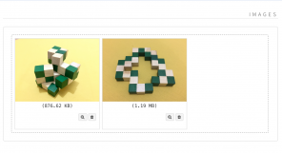

*Key Features*

It is a feature list expressed as the bullet points and is available at the top of the product description and detailed page. Adding this key feature list is highly recommendable as it helps improve the attraction for the customers. Also, the information in the list must be the main and important ones.

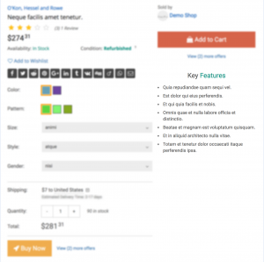

*Listing Rules*

It is the module that helps to list all the rules related to your stock like the number of products in the stock, the minimum amount of a certain product that a customer can buy, and pricing for the single units. Promotional prices and offers can be provided too for a limited period.

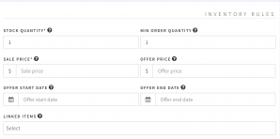

*Shipping Info*

All the shipping details including how the shipping will be provided, everything about the packaging, the shipping weight, the shipping cost, and all other related details are included from this module.

**Warning!** For weight-based shipping charges, the weight must also be added to the shipping info.

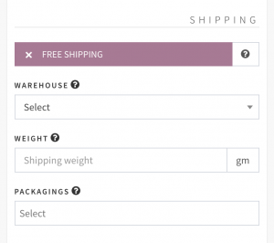

*Attributes*

SIZE, COLOR, STYLE, and other attributes can be added with this module. The attributes can also be added by your account if they are not visible, for this you must choose from the CATALOG ATTRIBUTE section.

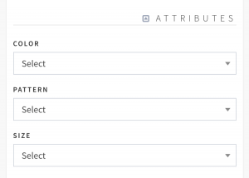

*Linked Items*

Related items with the product can also be added with a product listing to increase customer’s interest in your store and linked items too. These products will be shown as Frequently Brought Together. Only link the relevant items and not just anything!

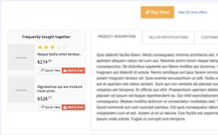

*SEO*

SEO friendly URL (SLUG) is a required field that can be automatically filled by the system itself. These are visible to the customers/ visitors when they visit the product page. With this feature, the marketplace, and eventually the store can directly attract the buyers from Google. Hence, this value is recommended to be set for higher customer acquisition.

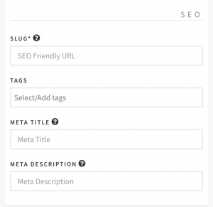

## Bulk Upload Inventory

## Inventory information can be bulk uploaded by CSV too. All the required instructions and templates are available on the CSV upload page for your reference.

## STOCK >> INVENTORIES >> CSV IMPORT

